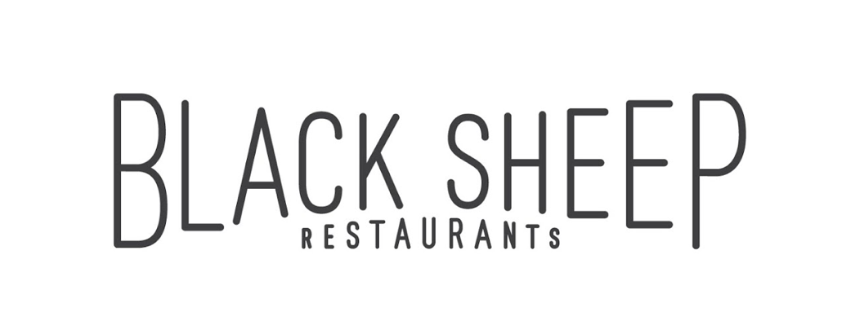

Black Sheep Restaurants is a Hong Kong-based hospitality group that specialises in developing niche, thought-provoking restaurant concepts that add to the existing culinary dialogue.

Whether recreating popular international concepts for the Hong Kong market or developing standalone restaurants, Black Sheep Restaurants curates distinct dining experiences that tell a story about a particular time, place, culture or cuisine while celebrating the bounty of premium ingredients available both locally and from abroad. The group currently boasts a portfolio of thirteen restaurants and bars, including Chôm Chôm, Motorino (Soho & Wan Chai), La Vache!, Ho Lee Fook, Carbone, Burger Circus, Stazione Novella, Le Garçon Saigon, BELON, Maison Libanaise, Buenos Aires Polo Club and Soul Food.

**BARTENDER**

**ROLES & RESPONSIBILITIES**

* Provide and serve food and beverages to guests
* Provide consistent, high quality beverage and service to guests
* Able to mix different cocktails
* Set up and tidy up the bar
* Ensure the cleanliness of the bar area
* Develop an in-depth understanding of the restaurants’ concepts, menus and wine lists
* Assist in other ad hoc projects as assigned

**REQUIREMENTS**

* Related working experience is preferred
* Good knowledge of wines, spirits and cocktails
* With a pleasant service min-dset and good attitude
* Ready to work hard, committed and be a good team player
* Good command in English, good in Cantonese/Mandarin would be an advantage
* Passionate in F&B industry

**Benefits**

* Competitive salary
* Quarterly discretional bonus
* Staff discount
* Education sponsorship program
* Related training provided